Kanban Board Template for Tracking Process Improvements
Use a visual board like one of the examples below to build a pipeline of improvement ideas and track progress as you complete them. This way the whole team can see and align around what’s happening.
Put post-it notes or the PDCA Worksheets on the board to represent “project” or “improvements” being made.
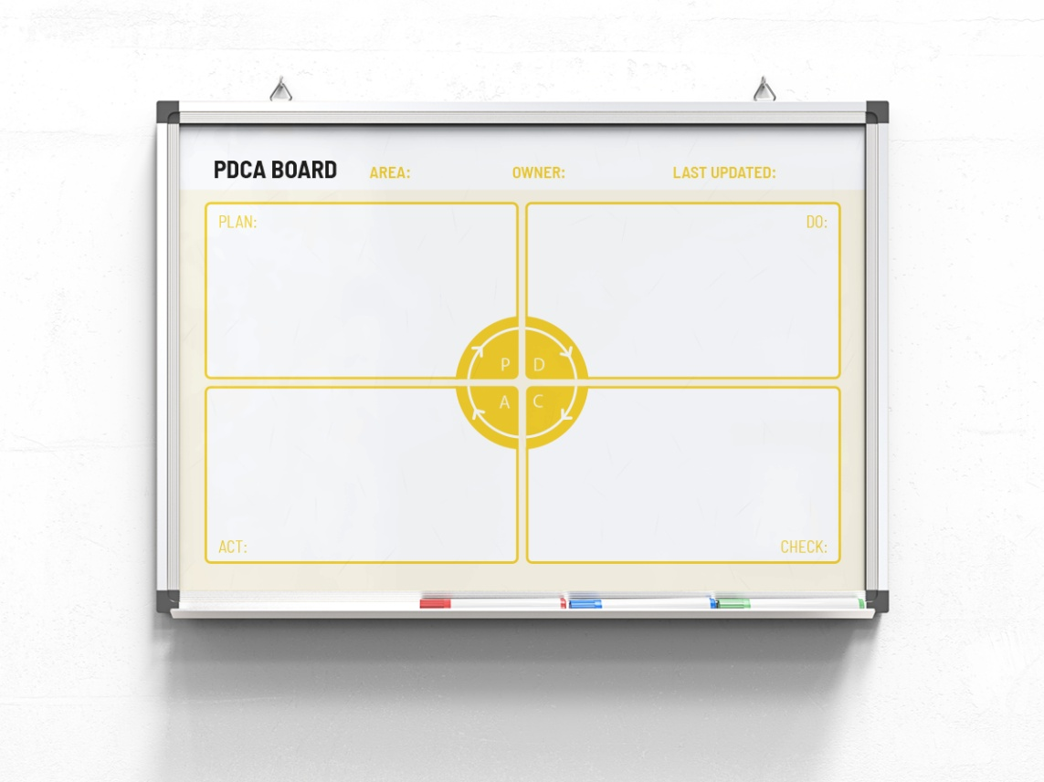
Another example:
